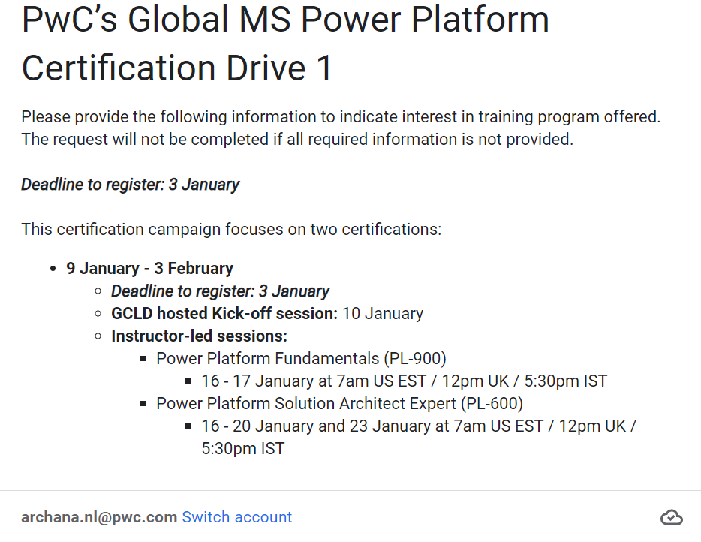

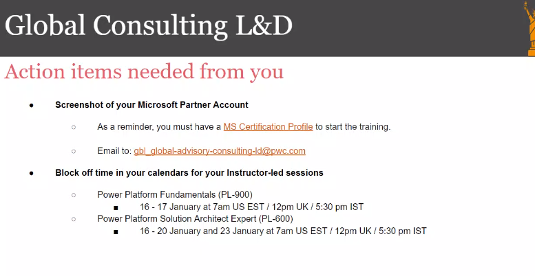

Contents

Introduction to Microsoft Power Platform 2

Introduction 3

What is Microsoft Power Platform? 3

The business value of Microsoft Power Platform 3

Data Connectors 3

Data loss prevention, compliance, privacy, and accessibility 3

Compliance and data privacy 3

Pulling it all together 3

Introduction to Dataverse 2

Overview of Dataverse 2

# Introduction to Microsoft Power Platform

## Introduction

Modern businesses run on data. Users interact with data daily from entering their time for payroll, seeking guidance on existing processes, and analyzing data to make decisions. In our technology driven world, users can be empowered to gain insights from and interact with data all while automating those menial responsibilities that seem to be more burden than job task. Microsoft Power Platform enables your business to craft solutions while empowering you to unite customized technology to help everyone, from the CEO to the front-line workers, drive the business with data.

In this module, you will:

* Learn the components and features of Microsoft Power Platform
* Identify when to use each Microsoft Power Platform component application to create business solutions
* Learn the value of using Microsoft Power Platform to create business solutions

## What is Microsoft Power Platform?

Microsoft Power Platform is composed of four key products: Power Apps, Power Automate, Power BI and Power Virtual Agents.



**Power Apps** provides a rapid low code development environment for building custom apps for business needs. It has services, connectors, and a scalable data service and app platform (Microsoft Dataverse) to allow simple integration and interaction with existing data. Power Apps enables the creation of web and mobile applications that run on all devices.  
People use apps for every area of their lives, and business should be no exception. Most out of the box solutions do not meet exact business needs or integrate well with other business programs. Power Apps eases users into app development with a simple interface so that every business user or pro developer can build custom apps.



**Power Automate** lets users create automated workflows between applications and services. It helps automate repetitive business processes such as communication, data collections, and decision approvals.  
Don't waste important productive hours on drafting the same email for a weekly update or walking approvals through. Not only for the individual user, Power Automate allows for the creation of enterprise-grade process automation. Power Automate's simple interface allows every level of user to automate work tasks - from beginners to seasoned developers.



**Power BI** (Business Intelligence) is a business analytics service that delivers insights for analyzing data. It can share those insights through data visualizations which make up reports and dashboards to enable fast, informed decisions. Power BI scales across an organization, and it has built-in governance and security allowing businesses to focus on using data more than managing it.  
You can consider Power BI as the analysis and insights leg of Microsoft Power Platform. It takes business data and allows you to display it in ways that makes the most sense to users. A Power BI dashboard could potentially replace a standing meeting to report out on company metrics such as sales data, progress against goals, or employee performance.



**Power Virtual Agents** enables anyone to create powerful chatbots using a guided, no-code graphical interface, without the need for data scientists or developers.  
It minimizes the IT effort required to deploy and maintain a custom solution by empowering subject matter experts to build and maintain their own conversational solutions. Power Virtual Agents is part of Microsoft Power Platform, therefore integration into existing systems is streamlined with out-of-the-box integration with Power Automate and its ecosystems of hundreds of connectors. Users can enable chatbots to perform an action by simply calling a Power Automate flow. Flows help users automate activities or call back end systems. Users can utilize existing flows that have been created in their Power Apps environment or they can create a flow within Power Virtual Agents authoring canvas.

Features

Among the programs listed above, there are cross cutting features which enable Microsoft Power Platform to be leveraged to its full potential. Some of these are:

**AI Builder** lets users and developers add AI capabilities to the workflows and Power Apps they create and use. AI Builder is a turnkey solution that allows you to easily add intelligence to your workflows and apps and predict outcomes to help improve business performance without writing code.

**Microsoft Dataverse** is a scalable data service and app platform which lets users securely store and manage data from multiple sources and integrate that data in business applications using a common data model to ensure ease and consistency to users. Microsoft Dataverse is the common currency that enables the components of Microsoft Power Platform to work together. It’s the foundation that enables the consolidation, display, and manipulation of data.

**Connectors** enable you to connect apps, data, and devices in the cloud. Consider connectors the bridge across which information and commands travel. There are more than 600 connectors for Microsoft Power Platform, enabling all of your data and actions to connect cohesively. Examples of popular connectors include Salesforce, Office 365, Twitter, Dropbox, Google services, and more.

Although every feature is essential to building powerful solutions, let's dive in deeper to one of the features of Microsoft Power Platform, connectors.

## The business value of Microsoft Power Platform

Many organizations struggle building solutions that help their users be successful. Not only do they struggle trying to modernize their systems, but they simply don't have the resources required to meet the ever-changing needs of businesses today. With demands for targeted applications at an all-time high and labor shortages, it isn't uncommon to see application demand up to five times what departments can realistically deliver.

This is not the only challenge facing enterprises today. As the business climate changes, new factors are impacting businesses. These impacts include:

* **Changing workforce expectations:** As millennials and Gen Z come to represent most of the workforce, organizations need to adapt to fit the way they work. They have grown up in a world of tailored experiences and collaborating through social media. To best apply their abilities, organizations need to be able to deliver more custom, streamlined, and collaborative digital experiences.
* **Increased costs for custom application development:** Building custom applications is time consuming and expensive. Not only do you need to factor in the costs to initially custom develop an application, but you need to factor in the costs to maintain it.
* **Need to become more agile:** Historically, solutions can take months to build and roll out. Once deployed, it can take weeks to implement every minor change. We no longer have that luxury. Business strategies and needs change rapidly, so organizations need to be able to quickly build solutions based on those changing needs.
* **Need to scale development efficiently:** To meet ever changing needs, organizations need to change how they develop solutions. By responsibly enabling citizens developers (Power Users) as part of development processes, we can create hybrid development teams that empower the entire organization to grow.

The Power Platform makes it easy for organizations to address all the challenges mentioned above. The combination of low code tools, along with the ability to leverage enterprise level application development tools, provide a collaborative solution where citizen developers and professional developers work together to build targeted solutions based on needs of the people who will be using these applications every day.

For example, technicians in the field may encounter scenarios in which they need a part to execute a job. Ideally if that part is in inventory, they can easily request the part so they can continue to work. However, many times, there's a bottleneck in this process. They need to submit a request to the parts person first. This means that they can be potentially spending time waiting for the parts person to get back to them only to find out later that the part isn't in stock. This could be easily solved by building a dedicated Power App. By being able to check inventory levels while onsite, technicians do not have to spend time onsite waiting to determine if the part is available. Not only can they see if the part is available, but they can easily request the part as needed. Since they best understand what they would need, they can use their first-hand knowledge of what would be required, to build out a prototype of the application using Power Apps that reflects the best user interface and overall experience. This is something that would have to be done by a developer in the past. Once prototyped, the organizations' developers can be used to fill in the gaps that go beyond the technician’s ability, such as developing the APIs that will do the checking in the company’s inventory system. Once created, the APIs can be easily added to the Power App and to any Power Automate Flows that may be needed. This collaborative approach to creating solutions is often referred to as Fusion development and allows organizations to use the best resources for the required task.

The image below provides an example the Fusion development approach.

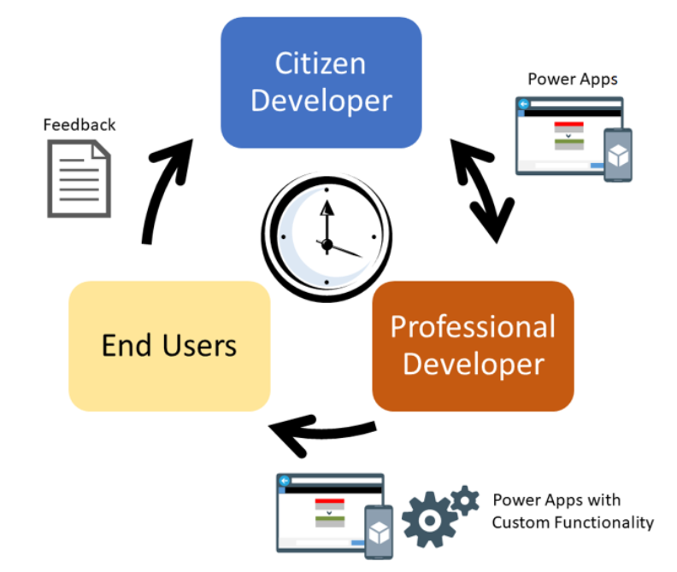

Leveraging a low code/no code approach minimizes the amount of time that development resources spend working on items like screens, automations, and more. This frees them up to focus on the more advanced portions of the solution where their skills are more appropriately used. Over 600 pre-built connectors help simplify integration with both internal and external systems. These connectors mean that organizations do not need to custom build integration solutions from the ground up, which can be costly both initially and to maintain.

In addition to the cost benefits provided by using Microsoft Power Platform, the Power Platform helps to increase performance and efficiency. The flexibility of the platform lets you build applications and solutions that meet your business initiatives and goals. For example, a dedicated time management Power App could be quickly created to ensure that everyone is capturing their time on projects the same way. This means that the potential for data entry errors would be dramatically reduced. Integrated approvals built on Power Automate ensures that items like time off requests and other items are being automatically routed to the right person, so they can approve or reject items as quickly as possible.

Microsoft Power Platform helps organizations build solutions that meet their ever-changing needs. Microsoft Power Platform gives organizations the ability to increase their business agility, by allowing them to quickly build application prototypes in hours or days, as opposed to weeks or months. This ensures by the time the solutions are created, it will still be something that provides value. The business value provided by Microsoft Power Platform extends beyond the value of the platform to the value of the apps themselves that are being built. These applications typically help improve one or more value drivers, such as performance improvement, direct or indirect cost savings, risk mitigation or business transformation. This allows organizations to have a library of applications to facilitate day to day operations. These apps might include solutions for facilities management, solutions to assist with employee onboarding, solutions for streamlining process, and more.

Now that we have examined the business value that is provided by Microsoft Power Platform, let’s examine the different components in more detail.

## Data Connectors

Microsoft Power Platform is made powerful by its ability to leverage data across many platforms. To do this, components of Microsoft Power Platform use connectors. You can think of connectors as a bridge from your data source to your app or workflow which allows information to be conveyed back and forth. Connectors allow you to extend your business solutions across platforms and add functionality for your users.

Data Sources

In order to understand the types of connectors and what you can do with them, you must first understand the types of data sources to which they connect. The two types of data sources are tabular and function-based.

**Tabular data** - A tabular data source is one that returns data in a structured table format. Power Apps can directly read and display these tables through galleries, forms, and other controls. Additionally, if the data source supports it, Power Apps can create, edit, and delete data from these data sources. Examples include Microsoft Dataverse, SharePoint, and SQL Server.

**Function-based data** - A function-based data source is one that uses functions to interact with the data source. These functions can be used to return a table of data but offer more extensive action such as the ability to send an email, update permissions, or create a calendar event. Examples include Office 365 Users, Project Online, and Azure Blob Storage.

Both of these data source types are commonly used to bring data and additional functionality to your solutions.

As you can see, connecting to data sources allows you to integrate disparate parts of your business solutions to build them out cohesively.

Connectors

Now that you understand more about data sources, you are ready to learn about connectors.

**Connectors** are the bridges from your data source to your app, workflow, or dashboard. Microsoft Power Platform has more than 600 connectors available to common data sources. Connectors are divided into standard and premium. Some popular standard connectors are SharePoint, Outlook, and YouTube. Premium connectors require additional licensing for your app and/or users. A few premium connectors are SQL Server, Survey Monkey, and Mail Chimp. The connector reference in the summary and resources unit lists all connectors and whether they are considered standard or premium. You can also use AppSource to source and install apps and use the connectors to non-Microsoft services.

Connectors can provide input and output between the data source and Power Platform, which can accelerate the delivery of Microsoft Power Platform business solutions. For instance, using Dynamics 365 apps such as Customer Service, you can set up Power Automate to notify users when specific customer types are added. Or you can use a SharePoint document library to store files that are fed into Power Apps to manage and distribute. Microsoft also provides connectors to their Azure services, providing advanced AI techniques to do tasks such as reading text off images or cognitive services like recognizing faces in images.

All Microsoft Power Platform business solutions can be used and implemented into Microsoft 365 apps such as Teams. This allows users to play Power Apps within Teams or run Power Automate from actions and events within Teams.

Triggers and Actions

Once you have established a data source and configured your connector, there are two types of operations you can use, triggers or actions.

**Triggers** are only used in Power Automate and prompt a flow to begin. Triggers can be time based, such as a flow which begins every day at 8:00 am, or they could be based off of an action like creating a new row in a table or receiving an email. You will always need a trigger to tell your workflow when to run.

**Actions** are used in Power Automate and Power Apps. Actions are prompted by the user or a trigger and allow interaction with your data source by some function. For example, an action would be sending an email in your workflow or app or writing a new line to a data source.

Now that you understand what connectors are and how to use them, let's look at what to do when there isn't a connector already built for your data source.

Custom Connectors

While Microsoft Power Platform offers more than 600 connectors, you also have the option to build a custom connector. This will allow you to extend your app by calling a publicly available API, or a custom API you are hosting in a cloud provider, such as Azure. API stands for Application Programming Interface and holds a series of functions available for developers. Connectors work by sending information back and forth across these APIs and gathering available functions into Power Apps or Power Automate. Because these connectors are function-based, they will call specific functions in the underlying service of the API to return the corresponding data.

An advantage of building custom connectors is that they can be used in different platforms, such as Power Apps, Power Automate, and Azure Logic Apps.

Creating Custom Connectors

You can create custom connectors using 3 different approaches:

* [Using a blank custom connector](https://learn.microsoft.com/en-us/connectors/custom-connectors/define-blank)
* [From an OpenAPI definition](https://learn.microsoft.com/en-us/connectors/custom-connectors/define-openapi-definition)
* [From a Postman collection](https://learn.microsoft.com/en-us/connectors/custom-connectors/define-postman-collection)

While the requirements for each approach will vary, they all require a Power Apps per app or per user plan. Each link above points to the instructions for each approach.

**Note**

The purpose of this module is to help you better understand data sources and connectors as a whole, but if you would like to learn more about custom connectors and even walk through an exercise to build one, check out the module [**Use custom connectors in a Power Apps canvas app**](https://learn.microsoft.com/en-us/training/modules/use-custom-connectors-in-powerapps-canvas-app/).

## Data loss prevention, compliance, privacy, and accessibility

Data loss prevention policies

Your organization's data is likely one of the most important assets you are responsible for safeguarding as an administrator. The ability to build apps and automation to use that data is a large part of your company's success. You can use Power Apps and Power Automate for rapid build and rollout of these high-value apps so that users can measure and act on the data in real time. Apps and automation are becoming increasingly connected across multiple data sources and multiple services. Some of these might be external, third-party services and might even include some social networks. Users generally have good intentions, but they can easily overlook the potential for exposure from data leakage to services and audiences that should not have access to the data.

You can create data loss prevention (DLP) policies that can act as guardrails to help prevent users from unintentionally exposing organizational data. DLP policies can be scoped at the environment level or tenant level, offering flexibility to craft sensible policies that strike the right balance between protection and productivity. For tenant-level policies, you can define the scope to be all environments, selected environments, or all environments except ones you specifically exclude.

Connectors can be classified as either **Business** or **Non-Business** in the context of your organization. Connectors that host business-use data should be classified as **Business** and connectors that host personal-use data should be classified as **Non-Business**. Any connectors that you want to restrict usage of across one or more environments should be classified as **Blocked**. When a new policy is created, all connectors are defaulted to the **Non-Business** group. From there they can be moved to **Business** or **Blocked** based on your preference. You can manage connectors when you create or modify the properties of a DLP policy from the [Microsoft Power Platform admin center](https://admin.powerplatform.microsoft.com/). These affect Microsoft Power Platform canvas apps and Power Automate flows. To create a DLP policy, you need to be a tenant admin or have the Environment Admin role.

## Compliance and data privacy

Microsoft is committed to the highest levels of trust, transparency, standards conformance, and regulatory compliance. Microsoft’s broad suite of cloud products and services are all built from the ground up to address the most rigorous security and privacy demands of our customers.

To help your organization comply with national, regional, and industry-specific requirements governing the collection and use of individuals’ data, Microsoft provides the most comprehensive set of compliance offerings (including certifications and attestations) of any cloud service provider. There are also tools for administrators to support your organization’s efforts. In this part of the document we will cover in more detail the resources available to help you determine and achieve your own organization requirements.

Data Protection

Data as it is in transit between user devices and the Microsoft datacenters are secured. Connections established between customers and Microsoft datacenters are encrypted, and all public endpoints are secured using industry-standard TLS. TLS effectively establishes a security-enhanced browser to server connection to help ensure data confidentiality and integrity between desktops and datacenters. API access from the customer endpoint to the server is also similarly protected. Currently, TLS 1.2 (or higher) is required for accessing the server endpoints.

Accessibility in Microsoft Power Platform

One of the things that Microsoft values the most is making sure that Power Platform is accessible and inclusive to all kinds of users all over the world. An accessible canvas app will allow users with vision, hearing, and other impairments to successfully use the app. In addition to being a requirement for many governments and organizations, following the below guidelines increases usability for all users, regardless of their abilities. You can use the [Accessibility Checker](https://learn.microsoft.com/en-us/powerapps/maker/canvas-apps/accessibility-checker) to help review potential accessibility issues in your app. For more details and suggestions on making your canvas apps more accessible, visit [Create accessible canvas apps in Power Apps](https://learn.microsoft.com/en-us/powerapps/maker/canvas-apps/accessible-apps).

## Pulling it all together

Although we live in a data driven world, your business can find it difficult to take advantage of the data you have access to. Sales, customer, and employee data should drive our business decisions, but where do we even start? Microsoft Power Platform can add value to any business by helping you to analyze, act, and automate. Act by building custom apps in Power Apps, automate processes based on the data you collect in Power Automate, and analyze the data you have collected in Power BI.

Consider a business that has IT equipment for general use. Currently, equipment check-out is conducted by visiting the IT office, checking if the product is available, then writing your name and the equipment name in a notebook. Employees may have to visit IT several times before equipment becomes available, and IT personnel must drop their tasks to check on equipment status or go to collect it for the employee. Sometimes employees hold onto the equipment longer than they intend and an IT personnel spends time tracking it down. In addition, important equipment information such as serial number, warranty details, and instructions for use are kept somewhere in the IT office. How can Microsoft Power Platform improve this process?

Power Apps allows us to build an app that has all equipment listed, the status of that equipment, and even important details such as use instructions. This way employees can check out available equipment, walk to IT at a specified pickup time where the equipment will be ready, and even access the use instructions or flag an equipment malfunction from their phone or tablet. Power Automate can read when equipment needs to be returned and send out reminder emails, or even a warning that the equipment is late being checked in. Users can see when equipment is booked through the app and request check-out for a future date at which time Power Automate can send them a reminder to pick up the equipment and IT a reminder to have it ready. Power BI can take all the data generated from the app and analyze it to help you understand what equipment is used most often and by whom. This way you can decide if you need other equipment, if some users or departments need dedicated equipment, and when your equipment has reached the end of its usefulness.

This is only one common scenario in which Microsoft Power Platform can transform the way businesses work. Consider your own business and what processes take up valuable time and are a burden to customers or employees. How can you leverage Microsoft Power Platform to improve them?

## Introduction to Dataverse

Microsoft Dataverse is a cloud-based, low-code data service and app platform, which allows you to leverage the security and connectivity of Microsoft services. Dataverse connects easily to all aspects of Microsoft Power Platform so that you can fully control, automate, and strengthen your business. With standard tables and columns, as well as the ability to easily define relationships between your data, Dataverse was built for powerful, scalable solutions.

In this module, you will:

* Explain what environments, tables, columns, and relationships are in Microsoft Dataverse
* Describe the difference between Microsoft Dataverse and Common Data Model
* Explain use cases and limitations of business rules and process flows

## Overview of Dataverse

Microsoft Dataverse is a cloud-based solution that easily structures a variety of data and business logic to support interconnected applications and processes in a secure and compliant manner. Managed and maintained by Microsoft, Dataverse is available globally but deployed geographically to comply with your potential data residency. It is not designed for stand-alone use on your servers, so you will need an internet connection to access and use it.

Dataverse is designed to be your central data repository for business data, and you might even be using it already. Behind the scenes, it powers many Microsoft Dynamics 365 solutions such as Field Service, Marketing, Customer Service, and Sales. It is also available as part of Power Apps and Power Automate with native connectivity built right in. The AI Builder and Portals features of Microsoft Power Platform also utilize Dataverse.

Below is a visualization that brings together the many offerings of Microsoft Dataverse.

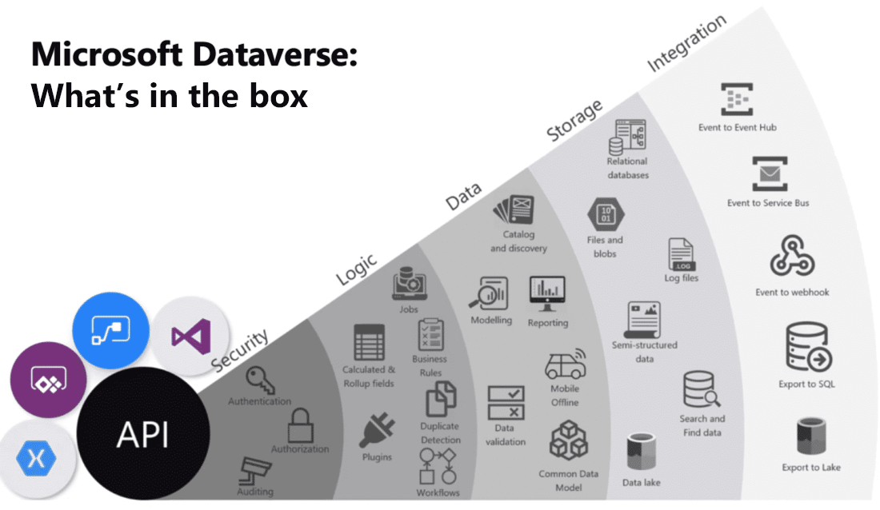

As you can see, Microsoft Dataverse offers a great deal of functionality. Below is a brief explanation of each category of features.

**Security**: Dataverse handles authentication with Azure Active Directory (Azure AD) to allow for conditional access and multi-factor authentication. It supports authorization down to the row and column level and provides rich auditing capabilities.

**Logic**: Dataverse allows you to easily apply business logic at the data level. Regardless of how a user is interacting with the data, the same rules apply. These rules could be related to duplicate detection, business rules, workflows, or more.

**Data**: Dataverse offers you the control to shape your data, allowing you to discover, model, validate, and report on your data. This control ensures your data looks the way you want regardless of how it is used.

**Storage**: Dataverse stores your physical data in the Azure cloud. This cloud-based storage removes the burden of worrying about where your data lives or how it scales. These concerns are all handled for you.

**Integration**: Dataverse connects in different ways to support your business needs. APIs, webhooks, eventing, and data exports give you flexibility to get data in and out.

As you can see, Microsoft Dataverse is a very powerful cloud-based solution for storing and working with your business data. In the following sections, you will look at Microsoft Dataverse from the lens of data storage for Microsoft Power Platform, where you will start your journey. Keep in mind the additional rich capabilities discussed above which you can explore further as your usage increases.

To get started, Microsoft Dataverse lets you create one or many cloud-based instances of a standardized database. The database includes predefined tables and columns which store data commonly found across nearly all organizations and businesses. You can customize and extend what is stored by adding new columns or tables. The ease of setting up a Microsoft Dataverse database and standardized data model under it simplifies your ability to concentrate your efforts on building solutions without worrying about infrastructure, storage, and data integration. With your data stored in Microsoft Dataverse, there are many different ways to access it. You can work with the data natively with tools such as Power Apps or Power Automate. Or through connectors and APIs you can connect to Microsoft Dataverse from any business solution. With the power of features such as role-based security and business rules you can trust your data is safe no matter how it is accessed.

Microsoft Dataverse defined

A Dataverse database is a single instance of Microsoft Dataverse which stores data in a set of standard and custom data structures called tables. A table is a logical set of rows that is used to store data. Rows within a table contain many columns to manage individual pieces of information about a single row.

You can create one or many database instances in Microsoft Dataverse to host data behind your business solutions. Each instance of a Microsoft Dataverse will start with the same set of tables to store data, but you can always extend and customize a Microsoft Dataverse database to meet specific business needs. This means that you can share business solutions that reference standard tables in Microsoft Dataverse across your organization or with any other organization by using it anywhere in the world.

Scalability

A Dataverse database supports large data sets and complex data models. Tables can hold millions of items, and you can extend the storage in each instance of a Microsoft Dataverse database to four (4) terabytes per instance. The amount of data that is available in your instance of Microsoft Dataverse is based upon the number and type of licenses that are associated with it. Data storage is pooled between all licensed users, so you can allocate storage as needed for each solution that you build. Additional storage can be purchased if you need more storage than what is offered within standard licensing.

**Tip**

Dataverse supports transactional multi-user applications, where quick response to user demand is the priority. It is not intended to be a platform for long running or batch processing.

Common Data Model vs. Microsoft Dataverse

The standard table design in a Microsoft Dataverse database is based upon an open data model standard called Common Data Model. Common Data Model is a logical design that includes a set of open-sourced, standardized, extensible data tables and relationships that Microsoft and its partners have published in an industry-wide initiative called the Open Data Initiative. This collection of predefined tables, columns, semantic metadata, and relationships form the basis of the Common Data Model.

Microsoft Dataverse structure and benefits

The structure of a Microsoft Dataverse database is based upon the definitions and schema in the Common Data Model. The key benefit of using Common Data Model as the basis of a Microsoft Dataverse database is simplified integration of any solutions that use a Common Data Model schema, because the standard tables of the solution are the same. You will also be able to take advantage of a rich ecosystem of solutions that vendors have built from using Common Data Model. Best of all, there is practically no limit to how far you can extend a Microsoft Dataverse database.

## Identify tables and columns in Dataverse

A table is a logical structure containing rows and columns that represents a set of data.

Below you can see a screenshot of the standard contact table and various types of columns it includes. [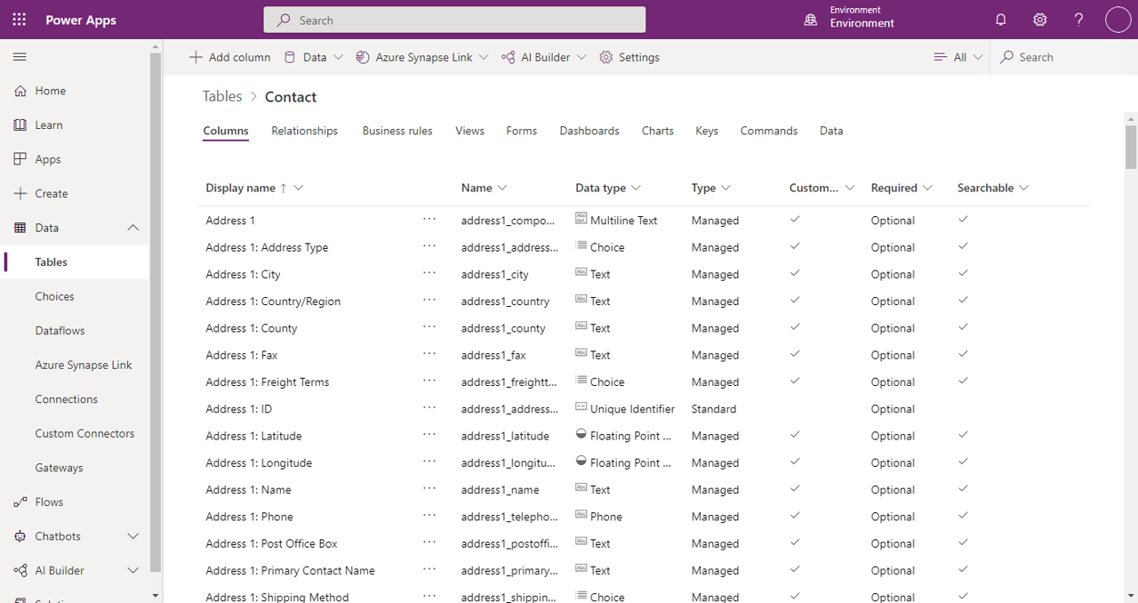](https://learn.microsoft.com/en-us/training/modules/introduction-common-data-service/media/contact-table-colums.png#lightbox)

Types of tables

The three types of tables are:

* **Standard** - Several standard tables, also known as out-of-box tables, are included with a Dataverse environment. Account, business unit, contact, task, and user tables are examples of standard tables in Dataverse. Most of the standard tables included with Dataverse can be customized. Tables that are imported as part of a managed solution and set as customizable also appear as standard tables. Any user with appropriate privileges can customize these tables where the table property has customizable set to true.
* **Managed** - Tables that aren’t customizable and have been imported into the environment as part of a managed solution.
* **Custom** - Custom tables are unmanaged tables that are either imported from an unmanaged solution or are new tables created directly in the Dataverse environment. Any user with appropriate privileges can fully customize these tables.

Columns

Columns are a way to store a discrete piece of information within a row in a table. You might think of them as a column in Excel. Columns have data types, meaning that you can store data of a certain type in a column that matches that data type. For example, if you have a solution that requires dates, then you would store the date in a column with the type of Date. Similarly, if you want to store a number, then you store the number in a column with the type of Number.

The number of columns within a table varies from a few columns to a hundred or more. If you need more than a few hundred columns in a table, you might want to reconsider how you are structuring data storage for your solution because, likely, there is a better way.

Every database in Microsoft Dataverse starts with a standard set of tables and each standard table has a standard set of columns.

**Tip**

Always use standard tables and columns when possible. You can rename a table if that makes the table more understandable in the context of your solution. Always review the list of standard tables and make sure a standard table will meet your needs before you create a new table.